1. (Palindrome Line)

using namespace std;

#include <iostream>

class Node

{

public:

char data;

Node* next;

Node()

{

data = '\0';

next = NULL;

}

};

class Stack

{

Node* top = new Node();

public:

Stack()

{

top = NULL;

}

bool isEmpty()

{

if (top == NULL)

return true;

else

return false;

}

void push(char item)

{

Node* newnode = new Node();

newnode->data = item;

if (isEmpty())

{

newnode->next = NULL;

top = newnode;

}

else

{

newnode->next = top;

top = newnode;

}

}

char pop()

{

char poped_item = '\0';

Node* temp = new Node();

temp = top;

poped_item = top->data;

top = top->next;

return poped_item;

delete temp;

}

void display()

{

Node* temp = new Node();

temp = top;

while (temp != NULL)

{

cout << temp->data << " ";

temp = temp->next;

}

delete temp;

cout << endl;

}

};

void check_palindrome(string string)

{

bool isPalindrome = true;

Stack stack;

int i = 0;

while (string[i] != '\0')

{

stack.push(string[i]);

i++;

}

i = 0;

while (string[i] != '\0')

{

if (stack.pop() != string[i])

{

isPalindrome = false;

break;

}

i++;

}

if (isPalindrome == true)

{

cout << endl << string << " is a palindrome :)\n";

}

else

{

cout << endl << string << " is not a palindrome :(\n";

}

}

int main()

{

string text;

cout << "Enter a line of text to check palindrome:\n";

cin >> text;

check_palindrome(text);

}

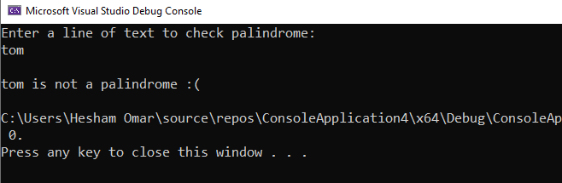

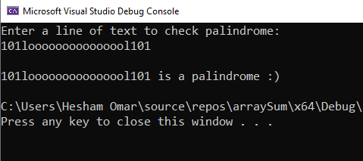

1. (Phone Book)

#include<iostream>

#include<string>

using namespace std;

class List

{

private:

int size = 0;

struct Node

{

string name;

long long number;

Node* prev = NULL;

Node* nxt = NULL;

Node(string s, long long n) { name = s, number = n; }

};

Node* head = NULL;

Node* tail = NULL;

public:

void add(string s, long long n)

{

if (head == NULL)

{

head = new Node(s, n);

tail = head;

}

else

{

Node* temp = new Node(s, n);

tail->nxt = temp;

temp->prev = tail;

tail = temp;

}

size++;

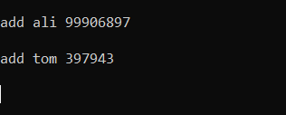 }

void remove(string s, long long n)

{

Node* node = head;

if (node->name == s && node->number == n)

{

head = node->nxt;

node = head;

return;

}

while (node != NULL)

{

if (node->name == s && node->number == n)

{

node->prev->nxt = node->nxt;

break;

}

node = node->nxt;

}

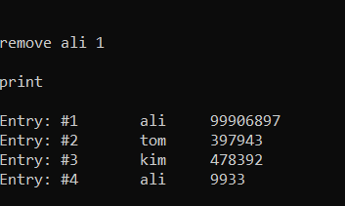 }

string search(string s/*, long long n*/)

{

int id = 1;

int found = 0;

Node* node = head;

while (node != NULL)

{

if (node->name == s /*&& node->number == n*/)

{

cout << "Entry: # " << to_string(id) << "\t";

cout << node->name << " ";

cout << node->number;

cout << endl;

found++;

}

node = node->nxt;

id++;

}

if (found ==0)

{

return "NOT FOUND";

}

else

{

return"";

}

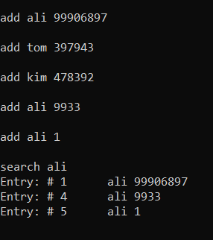 }

void print()

{

int id = 1;

Node* node = head;

while (node != NULL)

{

cout << "Entry: #" << id << "\t" << node->name <<

"\t" << node->number << "\n";

node = node->nxt;

id++;

}

}

};

void print_operations()

{

cout << "-+-+-+-+-+-+-+-+-+-+-+-\n";

cout << "operations:\n";

cout << "add (name, number)\n";

cout << "remove (name, number)\n";

cout << "search (name, number)\n";

cout << "print\n";

cout << "exit\n";

cout << "-+-+-+-+-+-+-+-+-+-+-+-\n\n";

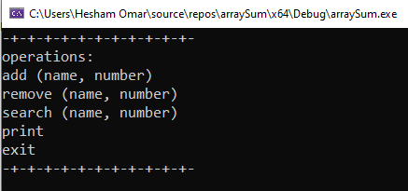}

int main()

{

List phonebook;

print_operations();

while (1)

{

string op, name;

long long number;

cin >> op;

if (op == "add")

{

cin >> name >> number;

phonebook.add(name, number);

cout << "\n";

}

else if (op == "remove")

{

cin >> name >> number;

phonebook.remove(name, number);

cout << "\n";

}

else if (op == "search")

{

cin >> name /*>> number;*/;

cout << phonebook.search(name/*, number*/) << "\n\n";

}

else if (op == "print")

{

cout << "\n";

phonebook.print();

cout << "\n";

}

else if (op == "exit")

{

exit(0);

}

else

cout << "invalid input\n";

}

return 0;

